Multi-objective optimization of I-section steel frames under TCVN 5575:2024: A comparative study of metaheuristic algorithms

Abstract. This paper investigates the multi-objective design optimization of welded I-section steel frames under the current TCVN 2737:2023 and TCVN 5575:2024 standards. A custom Finite Element Method (FEM) solver is coupled with a non-linear penalty function, and three metaheuristic algorithms — NSGA-II, PESA-II, and MOPSO — are applied to two conflicting objectives: minimizing structural steel weight and minimizing lateral frame displacement. The resulting Pareto fronts reveal clear differences in how each algorithm explores the search space; identifying the “knee-point” of each front helps select design configurations that are practical to build. Over 30 independent runs per algorithm, MOPSO converges 2.3–3.7 times faster than the other two methods, while PESA-II produces the best overall Pareto-front quality (highest hypervolume) and the most repeatable extreme-stiffness solutions. All three algorithms nevertheless settle on a nearly identical knee-point compromise, around 3520 kg and 6.8 mm of drift, which points to a robust, algorithm-independent design choice for practical steel-frame design.
Keywords: Multi-objective optimization; steel frames; pareto front; TCVN 5575:2024; metaheuristic; MOPSO; knee-point
- Introduction
Designing a steel frame is essentially a trade-off between material economy and lateral stiffness. Traditional single-objective methods tend to produce overly flexible structures, which is why Multi-Objective Optimization (MOO) based on metaheuristics has become the preferred approach: it yields a continuous Pareto trade-off instead of a single rigid solution. For engineering practice in Vietnam, the newly enacted TCVN 5575:2024 [1] adds severe non-linear constraints on member slenderness, local plate buckling, and out-of-plane stability, turning the feasible design space into a highly complex, discontinuous domain. To work within these code boundaries, this study builds an automated computational framework that couples an in-house Finite Element Method (FEM) engine with three well-established multi-objective solvers: NSGA-II [3], MOPSO [4], and PESA-II [5]. Newer swarm-intelligence variants often converge faster on unconstrained mathematical benchmarks, but their reliability under heavily codified structural constraints has not been rigorously verified; for this reason we deliberately choose these three well-documented algorithms, so that the mathematical accuracy of the resulting Pareto fronts can be trusted. Beyond identifying the most efficient solver for I-section geometries under the new code, this comparison also provides a reliable baseline against which future algorithmic developments in structural optimization can be evaluated [6].
- Framework and Computational Methods
  - Mathematical Formulation of the Structural Problem
Frame mass and lateral drift are optimized simultaneously, using an eight-dimensional continuous vector that defines the member cross-sections as design variables. Strength, global stability, and local buckling requirements from TCVN 5575:2024 are enforced through a non-linear static penalty function with a large multiplier (R) that penalizes any constraint violation. The in-house FEM solver evaluates the structural response for each candidate design and feeds it back to guide the three metaheuristics — NSGA-II, MOPSO, and PESA-II — each run for 30 independent trials with the same population size of 100 individuals (Section 2.2).

 | $$X=\{x_{1},x_{2},x_{3},x_{4},x_{5},x_{6},x_{7},x_{8}\}^{T}$$ | (1)
Where $x_{1},x_{2},x_{3},x_{4}$ denote the flange width, web depth, web thickness, and flange thickness of the column cross-section, respectively, while $x_{5},x_{6},x_{7},x_{8}$represent the corresponding geometric parameters of the beam section.
Side constraints: 0.20–0.50 m, 0.30–0.80 m, 6–18 mm, 8–22 mm for the column section (x1–x4), and 0.15–0.40 m, 0.25–0.60 m, 5–12 mm, 6–16 mm for the beam section (x5–x8).
 | $$f_{1}\left(x\right)=ρ\sum_{i=1}^{N_{e}}{A_{i}}\left(x\right)⋅L_{i}$$ | (2)
Where $ρ$ denotes the mass density of the steel material; $A_{i\left(x\right)}$ and $L_{i}$ represent the cross-sectional area and length of the i -th element, respectively; and $N_{e}$ indicates the total number of elements constituting the frame system.
 | $$f_{2}\left(x\right)=Δ_{max}\left(x\right)$$ | (3)
Where $Δ_{max}\left(x\right)$defines the maximum lateral displacement value at the top node of the frame, extracted directly from the finite element method (FEM) solver.
 | $$F_{k}\left(x\right)=f_{k}\left(x\right)+R\sum_{j=1}^{12}{{\left[\max\left(0,g_{j}\left(x\right)\right)\right]}^{2}}$$ | (4)
Where $F_{k}\left(x\right)$ and $f_{k}\left(x\right)$ denote the penalized and original objective functions for the k-th criterion, respectively; R represents the strictly large static penalty parameter; and $g_{j}\left(x\right)$ signifies the j-th behavioral constraint evaluated within the framework.
In practice, the twelve checks gj(x) (Section 2.1) are reduced to a single worst-case ratio r(x) = maxj gj(x); Eq. (4) is then applied in its equivalent multiplicative form Fk(x) = fk(x)·[1+λ(max(0, r(x)−1))²], λ = 5000.
  - Integration and configuration of metaheuristic algorithms
The numerical simulation is built around an in-house Finite Element Method (FEM) code coupled with a MATLAB-based TCVN 5575:2024 compliance-checking module, implemented on top of the Yarpiz evolutionary-computation templates [7]. Each design vector is translated into member forces and displacements, and the penalty mechanism of Eq. (4) uses this response to steer the search. NSGA-II and PESA-II generate a full offspring population every generation, whereas MOPSO only updates its existing swarm; consequently, the same iteration count does not represent the same computational effort for all three methods. To keep the comparison fair, all three algorithms use the same population size (100 individuals) and are each calibrated beforehand to spend the same budget of 30,000 objective-function evaluations (NFE), which corresponds to 227, 299, and 300 generations for MOPSO, NSGA-II, and PESA-II, respectively (Table 1). Each algorithm is then run for 30 independent trials under this shared budget so that the resulting Pareto sets and runtimes can be compared statistically.
Table 1. Specific computational variables and initial configurations driving the NSGA-II, MOPSO, and PESA-II routines.
Item | Algorithm parameters | MOPSO | NSGA-II | PESA-II
1 | Population size (Npop​) | 100 | 100 | 100
2 | Maximum iterations (Itermax​) | 227 | 299 | 300
3 | Inertia weight (w) | 0.9 | - | -
4 | Acceleration coefficients (c1​,c2​) | 2.0, 2.0 | - | -
5 | Crossover rate (pcross​) | - | 0.7 | 0.5
6 | Mutation rate (pmut​) | 0.5 | 0.3 | 0.5
7 | External grid size | 7x7 | - | 7x7
- Experimental results and discussion
  - Model description and FEM validation
To evaluate the three optimization frameworks, we analyze a benchmark two-story, single-span steel plane frame subjected to vertical gravity loads and the regional equivalent wind pressure. Before this structural model is embedded in the optimization loops, the in-house MATLAB-based FEM code is first checked against the commercial software SAP2000. Across all monitored nodes and elements, the maximum relative error in nodal displacement is only 0.0445%, which indicates that the in-house solver is precise enough to be used for evaluating structural response and objective values throughout the optimization runs.
Table 2. Summary of design variables and input constraints for the numerical frame simulation.
No. | Model parameters | Symbol | Applied value
1 | Main span / Frame spacing | L / B | 10.0 m / 6.0 m
2 | Story 1 height / Story 2 height | H₁​ / H₂​ | 4.0 m / 4.0 m
3 | Total vertical load (dead + live loads) | q_{v​} | 10.0 kN/m²
4 | Basic wind pressure [2] | W₀​ | 1.55 kN/m²
5 | Yield strength (SS400 steel) | f_{y}​ | 245 MPa
6 | Elastic modulus (SS400 steel) | E | 210000 MPa

Fig. 1. Frame configuration and loading diagram [2]
  - Pareto front exploration and knee-point identification
Pooling the non-dominated solutions from all three algorithms over the 30 runs produces a well-defined, convex Pareto front spanning roughly 2.0–7.5 t of mass and 3–18 mm of drift (Fig. 2). At the extremes, the three methods behave only slightly differently. For minimum mass, PESA-II and MOPSO are statistically indistinguishable (best-of-30 values of 1983.2 kg and 1983.7 kg; mean±SD of 2074±58 kg and 2108±79 kg), and both are lighter than NSGA-II (2041 kg best, 2141±70 kg mean). For minimum displacement, PESA-II is both the best (2.89 mm at 7546 kg) and the most repeatable (2.99±0.06 mm), ahead of NSGA-II (3.08 mm) and MOPSO (3.14 mm); this is consistent with PESA-II's higher average hypervolume (77.25±0.19, versus 76.15±0.69 for NSGA-II and 74.49±1.27 for MOPSO). NSGA-II, on the other hand, produces the most evenly spaced front (spacing of 0.0068±0.0006). Even with these differences, all three algorithms converge on almost the same knee-point, between 3503 and 3535 kg and between 6.75 and 6.91 mm, suggesting that this compromise solution does not depend on which algorithm is used.
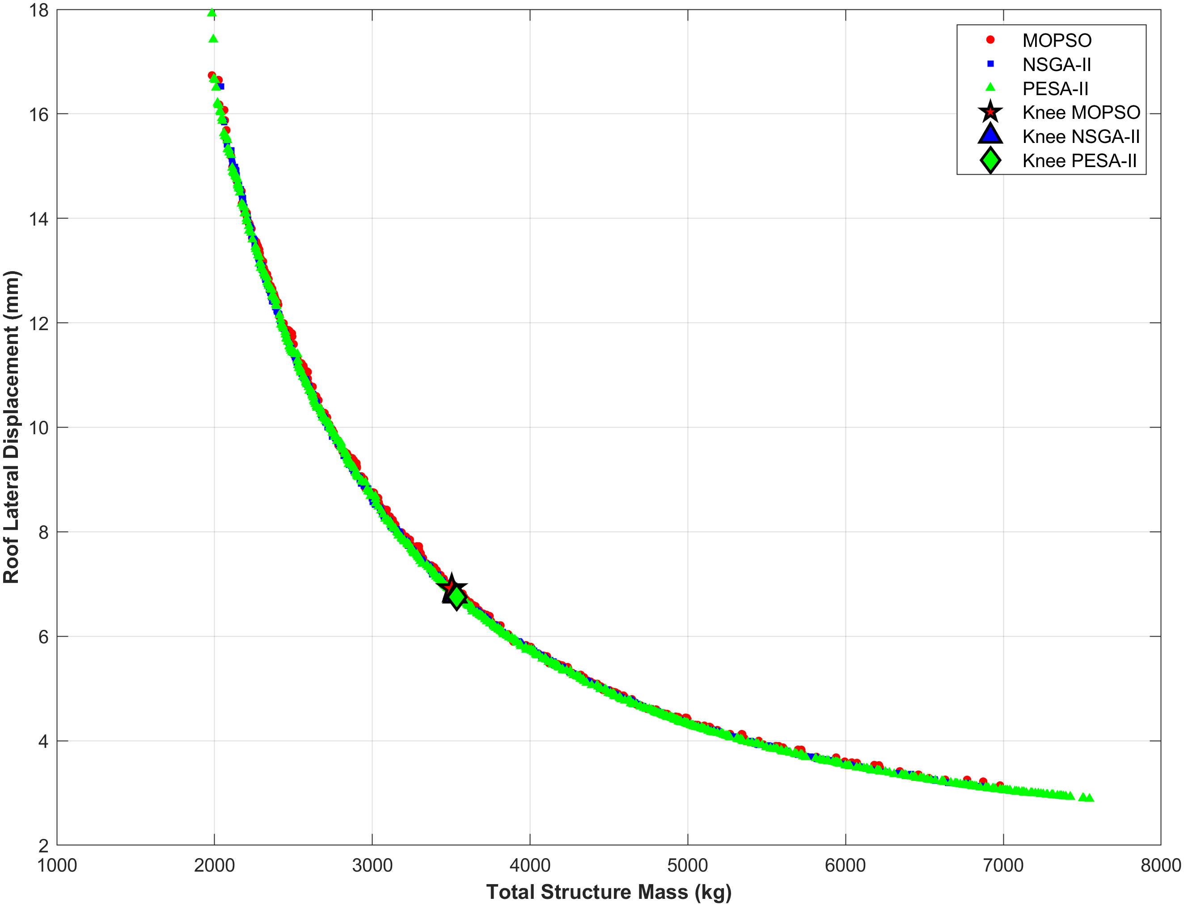
Fig. 2. Pooled non-dominated solutions (30 runs/algorithm) and consensus knee-points in the mass–drift trade-off space
  - Computational Efficiency Benchmarking
Repeatedly calling the finite element solver inside the optimization loop is computationally expensive. Timing the same 30 trials (Intel Core i5-1145G7 @ 2.60 GHz, MATLAB R2023b) shows that MOPSO is markedly more efficient: its average runtime of 32.95 s is 3.67 times faster than NSGA-II (120.82 s) and 2.29 times faster than PESA-II (75.49 s). Even MOPSO's slowest trial (49.4 s) finishes before NSGA-II's fastest one (69.2 s), which points to a consistent speed advantage rather than a one-off result. Although PESA-II gives slightly better solution quality overall (Section 3.2), MOPSO's speed advantage makes it the more practical choice for repeated, code-constrained optimization runs.
Table 3. Statistical metrics of computational runtimes (in seconds) over 30 independent runs.
Algorithm | Mean time  (tmean​) | Standard deviation (σ) | Fastest run (tmin​) | Slowest run (tmax​)
MOPSO | 32.95 | 7.84 | 20.44 | 49.39
NSGA-II | 120.82 | 20.92 | 69.23 | 149.21
PESA-II | 75.49 | 16.05 | 39.64 | 92.15
- Conclusions
This study presents an automated, FEM-based optimization framework for I-section steel frames designed under TCVN 5575:2024. The main conclusions are as follows.
Solver performance. MOPSO is decisively faster (2.3–3.7×, Section 3.3), while PESA-II achieves the best Pareto-front coverage (highest hypervolume) and the most consistent stiffest-design solutions; MOPSO and PESA-II reach almost the same minimum mass (about 1983 kg). None of the three algorithms dominates on every criterion.
Practical design application. All three algorithms converge on a common knee-point, 3503–3535 kg with 6.75–6.91 mm of lateral drift, which represents a robust design compromise that does not depend on the chosen algorithm.
The proposed methodology can be extended to more complex spatial structures. Future work will incorporate geometric-stiffness (P–Δ) effects and Reliability-Based Design Optimization (RBDO) to account for uncertainty in material properties and applied loads.

References
- Ministry of Construction, TCVN 5575:2024: Steel structures - Design standard. Construction Publishing House; 2024.
- Ministry of Construction, TCVN 2737:2023: Load and forces - Design standard. Construction Publishing House; 2023.
- Deb, K., Pratap, A., Agarwal, S., Meyarivan, T.: A fast and elitist multiobjective genetic algorithm: NSGA-II. IEEE Transactions on Evolutionary Computation 6(2), 182-197 (2002).
- Coello Coello, C.A., Pulido, G.T., Lechuga, M.S.: Handling multiple objectives with particle swarm optimization. IEEE Transactions on Evolutionary Computation 8(3), 256-279 (2004).
- Corne, D.W., Jerram, N.R., Knowles, J.D., Oates, M.J.: PESA-II: Region-based selection in evolutionary multiobjective optimization. Proceedings of the Genetic and Evolutionary Computation Conference (GECCO-2001), 283-290 (2001).
- Kaveh, A.: Advances in Metaheuristic Algorithms for Optimal Design of Structures. Springer Cham; 2021.
- Heris, M.K.: Yarpiz Evolutionary Algorithms Toolbox (YPEA). yarpiz.com (2015).

